## Arrays- Quiz 4

**What will be the order of the array elements at the end of the program?**

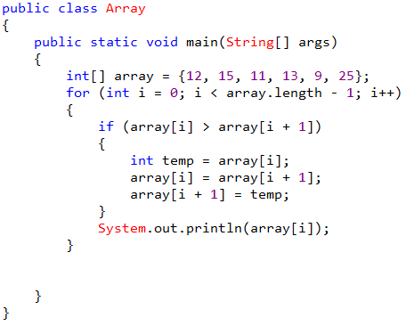

Choose only ONE best answer.

**A**

12, 15, 11, 13, 9

**B**

12, 11, 13, 9, 15

**C**

9, 11, 12, 13, 15, 25

**D**

Error

**The correct answer is 'B'**i iterates from 0 to 5 i = 0: array[0] > arra[1] = 12>15 condition fails it will not enters the body prints the value 12 i = 1: array[1] > arra[2] = 15>11 enters the body and executes the statement: temp = 15, array[1] = array[2] and array[2] = temp thus array[1] = 11 and array[2] = 15. Loop continues to iterates until the condition fails thus output of the above code is 12, 11, 13, 9, 15

**What will be the output of the code given below?**

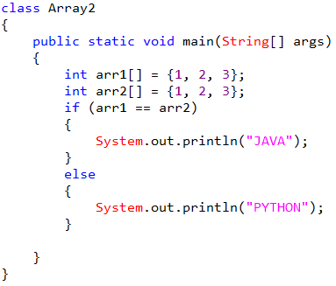

Choose only ONE best answer.

**A**

JAVA

**B**

PYTHON

**C**

Error

**D**

None of These

**The correct answer is 'B'**In the above code we are checking whether references are equal or not thus you will get the output as PYTHON

**Can you change the size of the array once you define it?**

Choose only ONE best answer.

**A**

No

**B**

Yes

Ans: A No

**What will be displayed by the following code?**

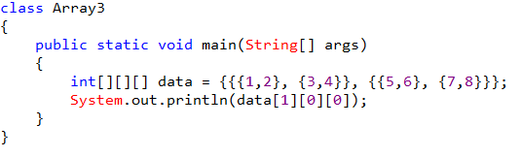

Choose only ONE best answer.

**A**

1

**B**

2

**C**

3

**D**

5

**The correct answer is 'D'**data[1] = {{5, 6}, {7, 8}}, data[1][0] = {5, 6}, data[1][0] [0] = 5 thus the output of above code is 5

**Predict the output of the code given bellow?**

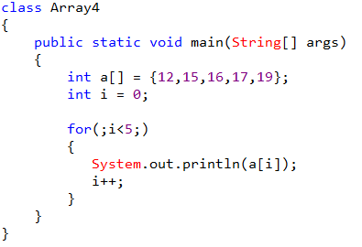

Choose only ONE best answer.

**A**

12 15 16 17

**B**

12 15 16 17 19

**C**

16 15 17 19

**D**

Error

Ans : B

**What is the default value present in char array?**

Choose only ONE best answer.

**A**

0

**B**

1

**C**

A'

**D**

a'

Ans : A [0]

**What is the output of the code given below?**

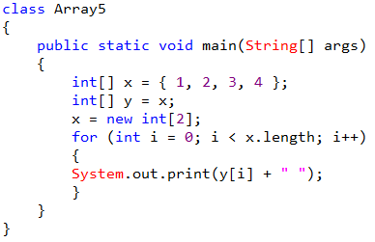

Choose only ONE best answer.

**A**

1 2

**B**

1 2 3 4

**C**

Error

**D**

None of These

**The correct answer is 'A'**x an array of type integer is assigned to y now y an array contains the value {1, 2, 3, 4}. One more array is created which is of size 2 which is assigned to variable x. in the next step for loop iterates from 0 to 1. i = 0: y[0] = 1 i = 1: y[1] = 2 Thus the output is 1 2

**How would you get the value 6 out of the following array int[][] a = {{2, 4, 6, 8}, {1, 2, 3, 4}};**

Choose only ONE best answer.

**A**

a[0][3]

**B**

a[1][3]

**C**

a[0][2]

**D**

a[2][0]

**The correct answer is 'C'**

**How many elements are there in the array matrix given bellow int[][] matrix = new int[5][5];**

Choose only ONE best answer.

**A**

14

**B**

20

**C**

25

**The correct answer is 'C'**5 rows and 5 columns thus 5*5 means 25 elements present in the matrix

**Predict the output of the following program?**

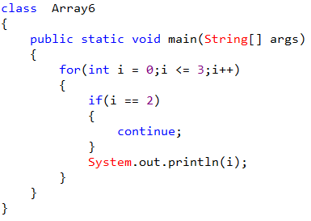

Choose only ONE best answer.

**A**

0 1 3

**B**

0 1 3 4

**C**

Error

**D**

0 1 2 3

**The correct answer is 'A'**In the above code loop iterates from 0 to 3 Whenever it encounters i = 2 it will executes the statement continue which will break that particular iteration and continues with next iteration as print statement is placed after if condition in the loop 2 will not printed. Thus the output of the above code is 0 1 3